WEEKLY LEARNING ACTIVITIES AT HOME
Our commitment to our families continues while your child/ren are not attending the centre. To support ongoing learning, we have created a calendar of ideas. These ideas are a guide. You can change and extend on these ideas. We would love for you to share what you have been learning about. Please send us photos and stories. Contact us if you have questions, ideas or require support.
BABIES & TODDLERS WEEKLY LEARNING ACTIVITIES- WEEK 2

Areas of learning | MONDAY 24-8-2020 | TUESDAY 25-8-2020 | WEDNESDAY 26-8-2020 | THURSDAY 27-8-2020 | FRIDAY 28-8-2020
STEAM  Children participate in a variety of rich and meaningful inquiry-based experiences | SCIENCE  Making Bath time fun! Add bath toys and  Experiment and explore how and why different objects float and sink | TECHNOLOGY  Make your own sorter  by Recycle empty milk carton pierce a hole to place items in and out or find empty container or tissue boxes | ENGINEERING  Create ramps with loose parts and send down all things that go e.g. car or ball! You can also introduce things That do not roll and see what happens? | ARTS  Make your own bottle shakers using natural or recycled materials  - Pinecones  - Gumnuts  - Leaves  - Pebbles  - Buttons  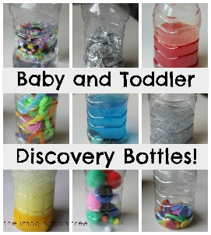 | MATHS  Making homemade playdough  - Talk about measurements when making the playdough
Community  Broaden their understanding of the world in which they live in | Social  Walk around your community hear for different sounds | Language  Can you name the different types of transport in your community | Road safety  Practice road rules:  Stop, Look, Listen, Think  https://www.youtube.com/watch?v=zP3DcpSSH34&feature=emb_logo | Posting  make a letter for friend or family if possible, you can mail it if they live far or walk to deliver | Letterbox  Can you identify different colours, shapes, patterns numbers on the letterboxes
Zoom meetings |  |  | Cooking healthy and colourful pizza  10:30am

