WEEKLY LEARNING ACTIVITIES AT HOME
Our commitment to our families continues while your child/ren are not attending the centre. To support ongoing learning, we have created a calendar of ideas. These ideas are a guide. You can change and extend on these ideas. We would love for you to share what you have been learning about. Please send us photos and stories. Contact us if you have questions, ideas or require support.
BABIES & TODDLERS WEEKLY LEARNING ACTIVITIES-
Week 6
Areas of learning | MONDAY 14-9-2020 | TUESDAY 15-9-2020 | WEDNESDAY 16-9-2020 | THURSDAY 17-9-2020 | FRIDAY 18-9-2020
STEAM  Children participate in a variety of rich and meaningful inquiry-based experiences | SCIENCE  Explore some coloured ice cubes and watch what happens to them.  What would happen if you added some water or salt?  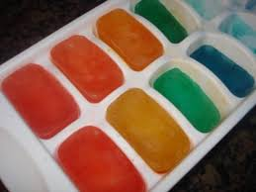 | TECHNOLOGY  Take some photos of the favourite things you have been learning at home and share them with us via email. | ENGINEERING  Take out your toy cars and trains and see how far they go when you push them.  Extension- try all different surfaces  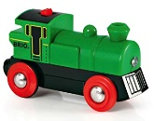 | ARTS  Make some markings with pencils, crayons, chalk or texta’s and share them with us. | MATHS  During shopping time explore the shapes and colours of different fruits.  How many fruits did you buy?  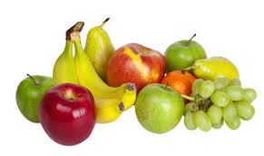
Community awareness  Broaden their understanding of the world in which they live in | Explore your backyard/front yard  What can you see?  What can you hear?  What can you smell? | Language  GO onto the listen to the Crocodile  https://raisingchildren.net.au/babies/play-learning/literacy-reading-stories/the-crocodile | Physical  When you go out for a walk observe the wind and see what it does with the tree’s flower and other things around you. | Music  Play and listen to some music from around the world  https://www.youtube.com/watch?v=iNv6XvRJQS4 | Next time you go shopping with mummy or daddy have a look at what fruit you can see?  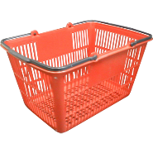
Independence | Breakfast time  Help prepare your breakfast by spreading your favourite spread on your toast or pour your cereal into a bowl | Lunch time  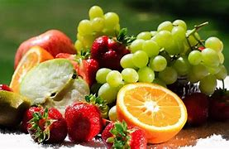  Can you pick one fruit with your lunch today and what may it be? What colour is the fruit? | Favourite activity  Participate in your child’s favourite activity of their choice | Dinner time  Set the table  Count how many people are in the house then work out how many plates and cups are needed for dinner | Bedtime  brush your teeth  What do I need?
Zoom meetings |  |  |  |  | 10.30am Story time  The very Hungry caterpillar  